**Sheet 4**

1. Sketch the output sequence in each case for the following input sequence X

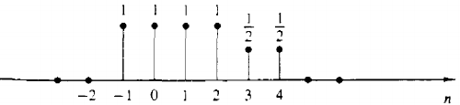

1. X(n-2)
2. X (-n+4)
3. X(n+2)
4. X(n) * u (2-n)
5. X(n-1) * δ (n-3)
6. X(n2 )
7. A discrete system can 1) static or dynamic 2) time invariant or time variant

Examine the following systems with respect to the properties above.

1. Y(n) = cos(x[n])

Ans: Static, time invariant .

1. Y(n) = x(-n + 2)

Ans : Dynamic, time variant.

1. y(n)=x(2n)

Ans: Dynamic, time variant.

1. y(n) = |x(n)|

Ans: Static, time invariant.

1. y(n) =Round[ x(n)] integer part of x(n)

Ans: Static, time invariant.

1. Find the sequence of Y(n)
2. Y(n)= u(n) -u(n-3) - 2 δ (n-1)

Ans: { …..,0, **1**, -1, 1, 0, …..}

1. Y(n)= u(n+2) -u(n) + 3 δ (n+1)

Ans: {……, 0, 1, 4, **0**, 0, …..}